Q1.
Answer is B.

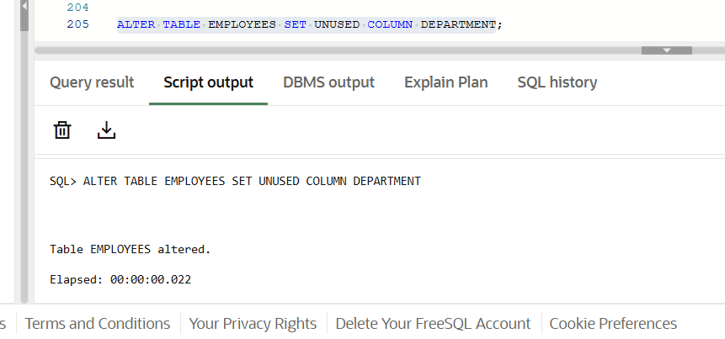

A: Invalid. This permanently removes the column and all its data.

B: Correct. This is safe and recoverable until the drop of unused columns.

C: Invalid syntax in Oracle SQL.

D: Also invalid syntax in standard Oracle SQL.

Q2.
Answer is B.

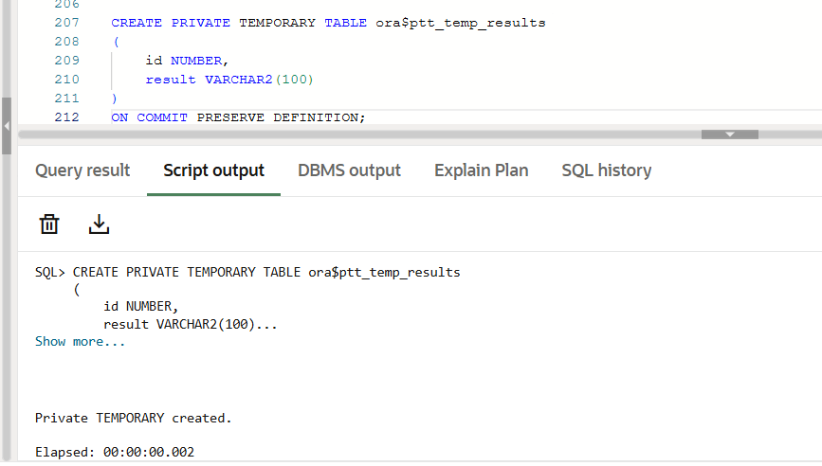

A: Invalid syntax in Oracle.

B: Valid. This is the standard way to create temporary tables in Oracle.

C: Also valid. create private temporary table.

D: Not valid in Oracle.

Q3.
Answer is A.

A: Oracle external tables are defined with CREATE EXTERNAL TABLE and use ORACLE_LOADER or ORACLE_DATAPUMP as the access driver.

B: CREATE TABLE ... EXTERNAL DIRECTORY ... is incorrect syntax in Oracle. You must use ORGANIZATION EXTERNAL.

C: USING CSV WITH HEADER ROW is not standard Oracle syntax; it looks like some other database (like PostgreSQL or Snowflake).

D: IMPORT EXTERNAL TABLE ... does not exist in Oracle SQL. Oracle cannot import external tables this way.

Q4.
Answer is D.

A: Uses a CHECK constraint to enforce both “not null” and “no future date” in one expression.Valid in Oracle, works correctly.

B: Invalid.

C: Invalid.

D: covers all requirements clearly at column level, including default value.Correct.

Q5.
Answer is A.

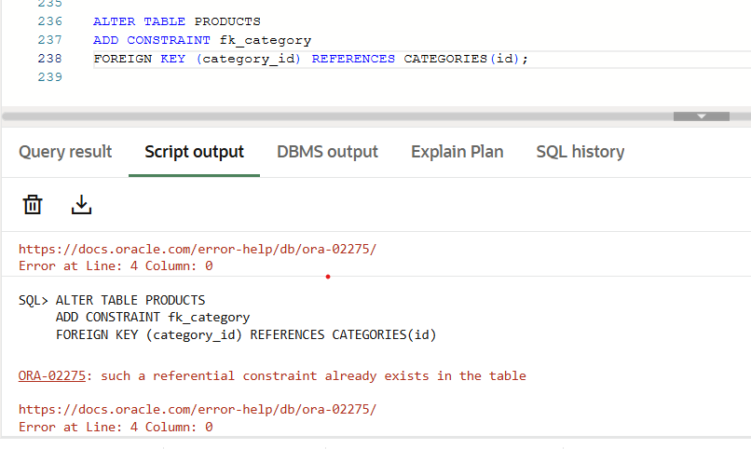

A: Correct. This is the standard way to define a foreign key after table creation.

B: Technically works in Oracle, but naming constraints is a best practice for easier management.

C: Incorrect syntax. CREATE CONSTRAINT is not valid in Oracle; constraints are defined with ALTER TABLE or during CREATE TABLE.

D: Incorrect syntax. MODIFY is used for changing column datatype or size, not for adding foreign keys.

Q6.
Answer is A.

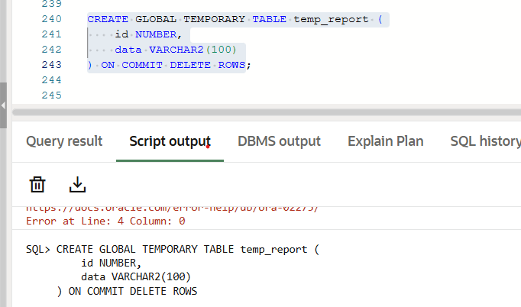

A: Table definition persists for the session; only data is deleted per transaction.

B: ON COMMIT PRESERVE ROWS keeps the data even after transaction commits, which does not meet the requirement.

C: Incorrect syntax in Oracle.

D: Incorrect syntax in Oracle.

Q7.
Answer is

A: Not ideal for CSV file.
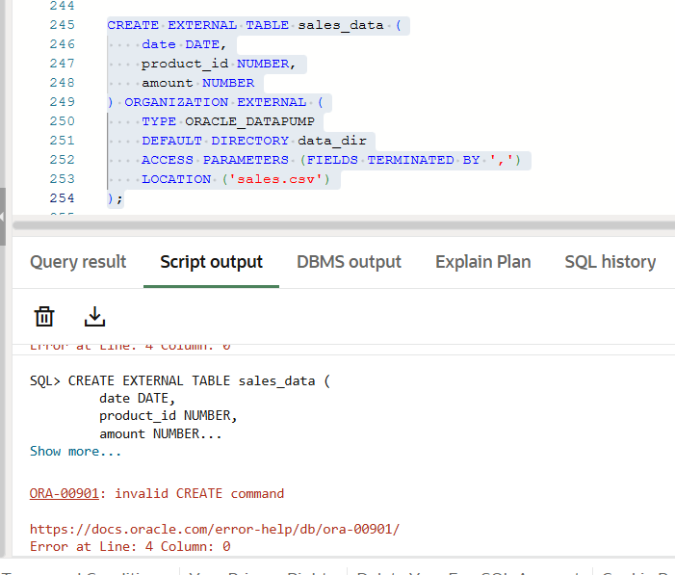

B: CSVREAD is not supported in Oracle SQL.
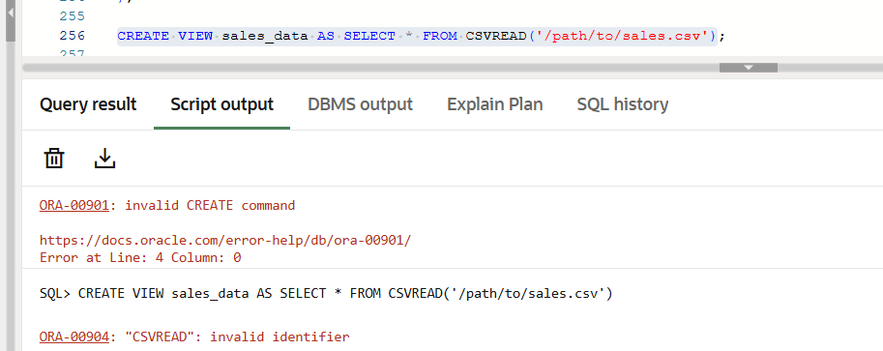

C: Same issue as B. CSVREAD is not valid in Oracle, so this won’t work.

D: Correct choice.
EXTERNAL TABLE with ORACLE_LOADER directly reads CSV files.
Oracle treats the external table like a regular table without importing the data.
Data is always read from the CSV file, so daily updates are automatically reflected.
RECORDS DELIMITED BY NEWLINE ensures each row in the CSV is treated correctly.

Q8.
Answer is C.

A: This sets a default timestamp only at the time of insertion. It does not update automatically on row updates, so it does not fully satisfy the requirement.

B: ON UPDATE SYSTIMESTAMP is not valid syntax in Oracle SQL. This is more like MySQL syntax, so it won’t work in Oracle.

C: Adds the column with a default timestamp for inserts.Creates a trigger that automatically updates last_updated on insert and update. Correct.

D: A virtual column cannot store values in the table; it’s computed at query time.It cannot be updated or used as a real timestamp for auditing, so it doesn’t meet the requirement.

